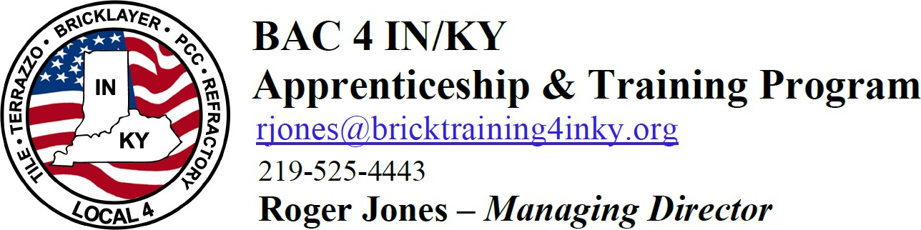

Monthly Evaluation (Timecard) Policy

All monthly evaluation sheets will be signed and turned into your State Instructor by the 15th of the following month.

Any falsified timecards will result in the immediate release from the program.

Your signature below certifies that I understand the above policy.

Signature: Date .

Print full name: .

